USER MANUAL - 2019
please read this instruction manual thoroughly before using this product and save it for future use.

Thank you for purchasing equipment from Mobility Sports LLC. To ensure proper operation, please read this instruction manual thoroughly before using. Also, when undertaking maintenance, inspection or repair work, be sure to refer to this manual. If you have any questions regarding our products, please contact us 734.925.1585, or visit our website www.mobilitysports.com.

Legal Disclaimer:
Mobility Sports LLC will not be held liable for any incidental or consequential damages for breach of any expressed or implied warranty of our equipment, nor an incidental, or consequential damages from the inability to use, or ability to use our products. Under no circumstance shall Mobility Sports LLC, liability exceed the purchase price of the product as sold by Mobility Sports LLC. Mobility Sports LLC reserves the right to refuse to honor this warranty if any of above exceptions caused the product design and/or structural integrity to fail.

All players using Mobility Sports LLC equipment assume all risk associated with using our products. When using Mobility Sports LLC equipment, user must wear all protective gear as required by USA Hockey.

Copyright:
All of the information found on the www.mobilitysports.com is copyrighted by Mobility Sports LLC. All rights reserved. All U.S. and International patent and trademark infringement/misuse will be prosecuted to the fullest extent of the law. This includes violations of infringements of design, manufacturing, concept or utility patents currently covered or pending patents to be issued. Any and all trademarks, representations, and copyrights are trademark of their respective owners.

Warranty:
Mobility Sports LLC warrants our products (with the exception of carbon fiber and composite sticks) against defect in workmanship and materials for a period of 90 days from the original date of purchase. If Mobility Sports LLC determines the product is defective, subject to the limitations of this warranty, it will be replaced at no charge, excluding shipping, for labor and/or materials.

Stick Warranty:

While we have done our best to ensure our wooden sticks have a long life, they are after all wood, and sometimes do break.

We offer a 30-Day Replacement Warranty; on all of our sticks, from the date of purchase. Shipping and handling are not included on any replacement stick.

In the event of a stick breaking during the warranty period, please follow the directions below:

- In the event of a stick breaking, prior to the expiration of the warranty, please notify us with an email at sales@mobilitysports.com.
  - Tell us the original order number.
  - Tell us how the stick broke.
  - Whether or not it is a left stick or a right stick.
  - Where on the stick that it broke, as well as a picture for our records.
  - Once we have received this information, we will contact you with further instructions.

Dear Valued Customer,

I would like to personally thank you for your business and support. We here at Mobility Sports LLC take great pride in our products and we are delighted to have you as a customer. Without you we would not be where we are as a company today. We value all the opinions and suggestions from our customers.

As you will see on the following pages, assemblies of our products are very self-explanatory and can be completed in a very timely manner. However, if you experience any difficulty please contact us 734.925.1585 or www.mobilitysports.com and we will do our best to resolve your issue.

Again, thank you for your business and we hope you are a customer for many years to come.

Sincerely,

Randal J Kwapis

Randal J Kwapis
President Mobility Sports LLC
Assembly:

Tools Needed:

7/16inch wrench
1/2inch wrench
3/16inch allen wrench
5/32inch allen wrench
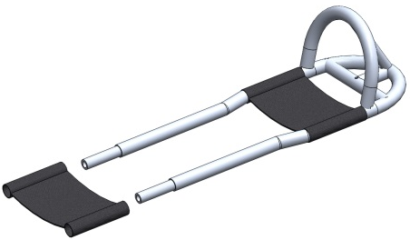
1/4inch allen wrench

Assemble Sled:

- Slide Foot Rest over tubes.

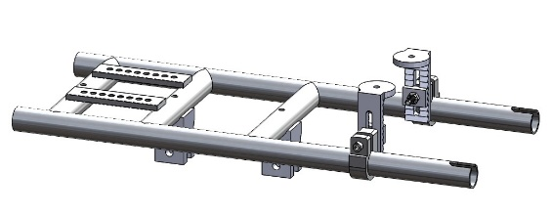

- Attach Bucket Stabilizer Assembly. PLEASE NOTE BUCKET STABLILIZER IS NOT USED WITH X-SMALL (10INCH) BUCKET.

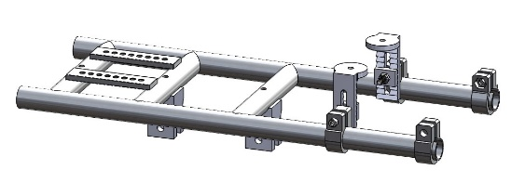
- Attach bicycle style clamps to slotted ends of tubes. To minimize contact between the clamps and the ice, it is recommended the clamps be oriented as shown.

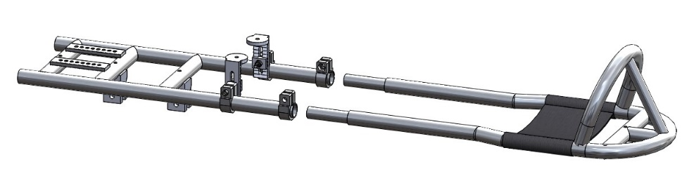
- Attach and then Slide smaller sized tubing into side tubes and loosely tighten bicycle style clamps with 1/4inch allen wrench.

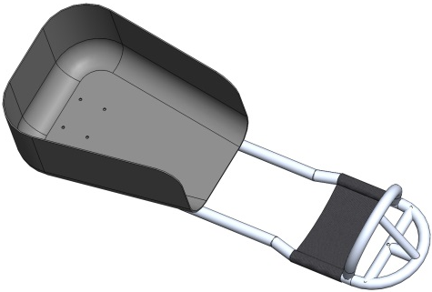
- Attach bucket using 5/32inch allen wrench and four 1/4inch button head bolts with fender washers and 7/16inch lock nuts.

- Attach Thermal Bottom and Back using provided Velcro. Attach optional hip pads, at this time, using provided Velcro.

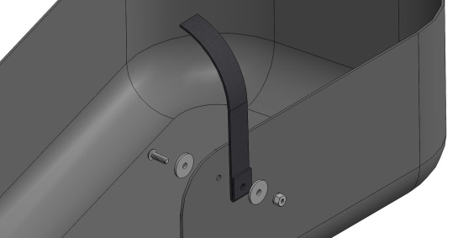
- Attach Team Strap Kit following this example for each strap, using provided hardware and a 5/32inch allen wrench and a 7/16inch wrench. TO MINIMIZE PREMATURE STRAP FAILURE, MAKE SURE BUTTON HEAD BOLT GOES THROUGH BOTH STRAP HOLES.

- Attach Skag (Nylon shown, U-Bolt standard) to front of sled, using 1/2inch wrench and 2 supplied nuts.

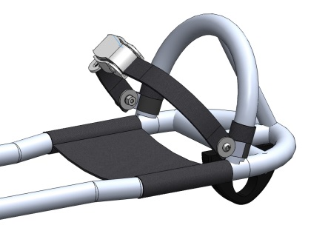
- Attach Ankle strap using supplied clamps, nuts and bolts. To keep strap from sliding up, we recommend wrapping stick tape above the clamp. Use caution when tightening ankle strap over feet. overtightening can limit circulation.
- Attach Blade Assembly to sled frame using 1/4inch allen head bolts and 1/2inch nuts and loosely tighten bolts. Prior to first use bolts must be firmly tightened to keep blade assembly from moving while sled is in use.

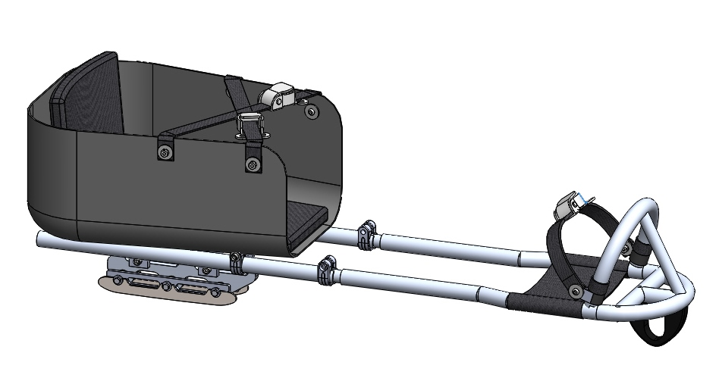

Assembled Program Sled

adjust sled for use:

- With player sitting in sled, adjust length of sled so players feet are resting on footrest with a slight bend at the knee securely tighten bicycle style clamps with 1/4inch allen wrench.

- To achieve proper position of blade assembly:

  - With player sitting in sled on hard surface, move blade assembly to the rear and then move it slowly forward until front of sled lifts off the surface. Tighten bolts using a 1/4inch allen wrench and a 1/2inch wrench.

  - Please note: For beginning players, the sled will be most stable with the blades in the rear position as shown above.

  - Note: By positioning sharply angled end of blade assembly toward the front of the sled; as shown below, you can move the blades approximately 1-inch further to the rear and by positioning the sharply angled end toward the read of the sled you can position the blades approximately 1-inch further forward.

Bucket Stabilizer:
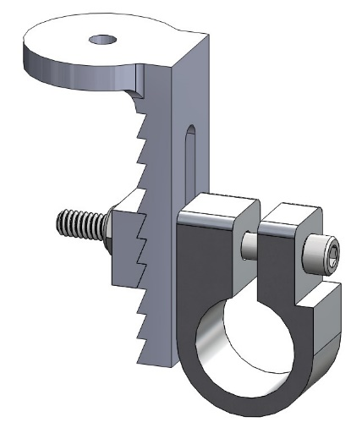
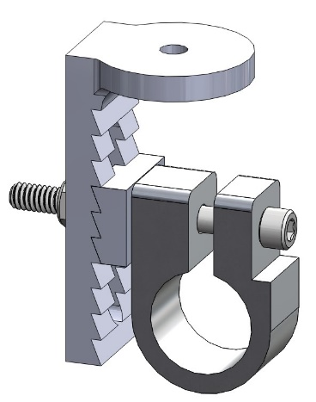

Competition Sled Configuration Program Sled Configuration

Tools Needed:

7/16inch wrench
3/16inch allen wrench
5/32inch allen wrench
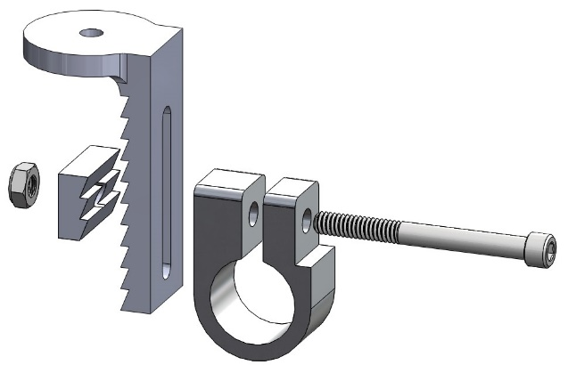

Mounting Instructions:

- Using the contents of the Bucket Stabilizer bag, assemble Stabilizer using the configuration of sled you are assembling.

- Slide the bucket stabilizer onto the frame of the sled.
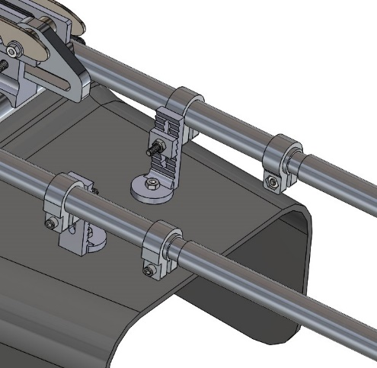
- Position bucket so holes in back and front of the bucket line up and the bucket is square to the frame and then attach bucket with 1inch button head screws and 7/16inch nuts (labeled Seat Bolts) Securely tighten all nuts and bolts.

- Note: Bucket stabilizer is intended to stabilize the front of the bucket and not create dump.
- PLEASE NOTE BUCKET STABLILIZER IS NOT USED WITH X-SMALL (10INCH) BUCKET.

Blade Assembly:

Blade Backer Qty. 2 Blade Holder Qty. 1

Blade Qty. 2

Spacer Kit – shafts (3) and spacers (6)

Tools Needed:

7/16inch wrench two (2) needed

CAUTION, BLADES ARE EXTREMELY SHARP, wear protective gloves and use CAUTION whenever making adjustments to or near the blade assembly.

All Team Sleds come standard with 4inch, 3inch, 2inch and 1inch spacer kits, allowing teams to adjust blade width as player skills advance.

Optional spacer kits starting at 1/2inch are available for purchase from www.mobilitysports.com

Blade Assembly: 4 INCH BLADE SPACING:

- Insert three (3) 4inch spacer shafts into blade holder
- Slide six (6) of the 1inch (silver) spacers, and six (6) of the 1/2inch (blue) spacers, over the spacer shafts
- Slide backer plate up against colored spacers
- Attach blades, using three (3) 4-1/2inch bolts, washers and lock nuts

Blade Assembly: 3 INCH BLADE SPACING:

- Insert three (3) 3inch spacer shafts into blade holder
- Slide six (6) of the 1inch (silver) spacers, over the spacer shafts
- Slide backer plate up against colored spacers
- Attach blades, using three (3) 3-1/2inch bolts, washers and lock nuts

Blade Assembly: 2 INCH BLADE SPACING:

- Insert three (3) 2inch spacer shafts into blade holder
- Slide six (6) of the 1/2-inch (blue) spacers, over the spacer shafts
- Slide backer plate (up against colored spacers
- Attach blades, using three (3) 2-3/4inch bolts, washers and lock nuts

Blade Assembly: 1 INCH BLADE SPACING:

- Insert three (3) 1inch spacer shafts into blade holder
- Slide backer plate up against blade holder
- Attach blades, using three (3) 1-3/4inch bolts, washers and lock nuts

Pusher Handle (Optional):

Tools Needed:

7/16inch wrench two (2) needed
1/4inch allen wrench

Pusher Handle Assembly and use:

- Attach bicycle style clamps to end of tubes.

- Insert 4inch tubes into end of tubes and attach using provided ¼-20 x 1-1/4inch bolts and nuts.

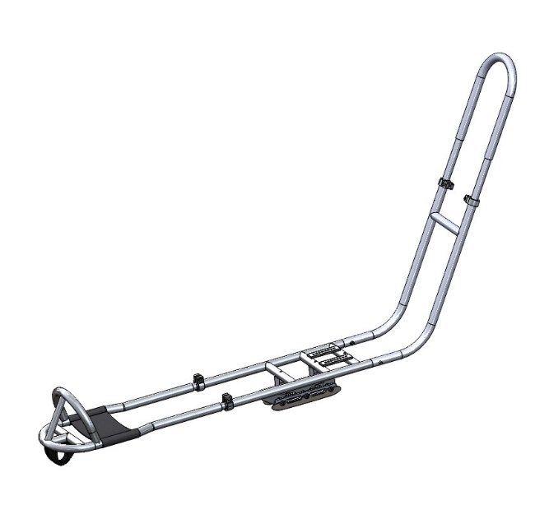
- Slide smaller sized tubing into side tubes and loosely tighten bicycle style clamps with 1/4inch allen wrench.

- Slide Pusher Handle in to the rear of the sled. (seat removed for clarity)

- Adjust height of pusher handle and tighten bicycle style clamps.

- Pusher handle is designed to push the sled, it is possible when attempting to pull the sled, with a player seated; the handle may disengage from rear of sled. To minimize this, push down slightly on the handle when pulling.
Bolt-On High Back (Optional):

Tools Needed:

7/16inch wrench
5/32inch allen wrench
Drill with 5/16inch drill bit (if bucket and back have not been pre-drilled)

Mounting Instructions:

- Position the high back about 4inches into the bucket. Make marks indicating where holes must be drilled.

  - Note: We recommend drilling holes in a diamond pattern. Also make sure marking utensil is able to be seen on the bucket.

- Remove high-back and use 5/16inch drill bit to drill holes where previously indicated.

- Reinsert high-back in same location as before and this time mark on the bucket as to where holes should be drilled.

- Remove high-back to drill holes in bucket then reinsert into bucket to ensure that the holes match.

- Secure tightly with provided bolts, nuts and washers.

Anti-Tipper (Optional):

Tools Needed:

7/16inch wrench
5/32inch allen wrench
1/4inch allen wrench

Mounting Instructions:

- For ease of attaching anti-tippers, it is recommended that the bucket and blade assembly be removed.

- Position provided vinyl covered clamps.

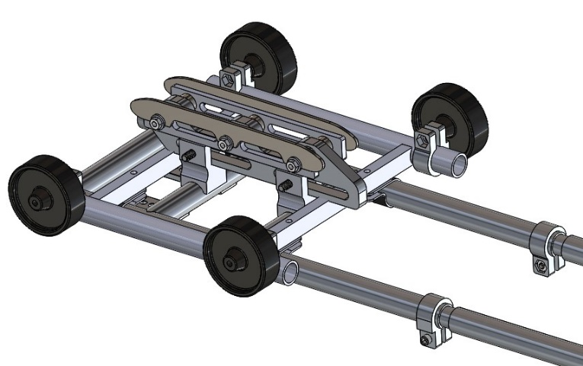
- Position anti-tipper frame as shown and attach with provided hardware.

- Reattach blade assembly and bucket.

Notes:
Wheels are intended to slide on the ice and do not rotate.
Make sure to tighten wheels firmly in a vertical position.
By angling wheels, user will be able to tip from side to side.

Blade care:

The blades on your new Mobility Sports sled have been engineered using a high-quality American made tool steel. They are hardened and nickel plated to minimize corrosion. However, unless properly maintained, these blades can rust.

Please follow these instructions to insure your blades last for many seasons:

- Be sure to dry your blades after each ice session.

- When transporting any sled, we recommend using a protective bootie which can be purchased at any pro ship. THE PROTECTIVE BOOTIE IS FOR TRANSPORT ONLY AND SHOULD BE REMOVED WHEN STORING AS LEAVING IT ON WILL PROMOTE RUST.

- Periodic oiling of your blades will assist in preventing rust.

- These blades have been pre-sharpened using a ½” ROH.

- We recommend having your blades sharpened often to provide the best performance on the ice.

Tips and Maintenance:

- Applying a small amount of lubricating oil such as 3-IN-ONE on the small tubes of the nose piece will allow it to more easily slide in and out.

- Before each use make sure all nuts and bolts are tight.

- OPTIONAL Padded Ratchet Strap (PRS) -- When installing a PRS, a standard nylon strap with cam buckle is mounted on the front of the bucket and the PRS is mounted in the rear.

